**The Sparks Foundation**

**Oct’2020**

**Web Development Internship**

**Task4 : CI/CD Cloud Computing**

**Objectives:**

◇ Write up about the steps of setup and essentials of AWS EC2

◇ Create an EC2 or azure VM instance and access it through SSH from your pc over internet.

◇ In the EC2, deploy and run any application project.

◇ Use at least one service apart from EC2 or VM, i.e. Database service, or MQ, ML, Mobile or any other services provided by AWS or Azure.

**SUBMITTED BY :GUNJAN PURWAR**

**STEPS TO LAUNCH AN EC2 INSTANCE AND CONNECT THROUGH SSH.**

1. **Create an account on Amazon Console . They give you free usage facility for one year on certain services. EC2 is one of them.**
2. **Open the Amazon EC2 console at**[**https://console.aws.amazon.com/ec2/**](https://console.aws.amazon.com/ec2/)**.**

**Choose Launch Instance.**

1. **Choose an Amazon Machine Image (AMI), find an Amazon Linux AMI at the top of the list and choose Select.**
2. **Choose an Instance Type, choose Next: Configure Instance Details.**
3. **Configure Instance Details, provide the following information:**
4. **Choose Next: Add Storage.(optional)**
5. **Choose Next: Add Tags.(optional)**
6. **Name your instance and choose Next: Configure Security Group.**
7. **In Step 6: Configure Security Group, set Assign a security group to Select an existing security group. Choose the default security group to make sure that it can access your EFS file system.**
8. **To access EC2 instance by Secure Shell(SSH),create a new security group that allows SSH. You can use the following settings to add SSH access:**

* **Type: SSH**
* **Protocol: TCP**
* **Port Range: 22**
* **Source: Anywhere 0.0.0.0/0**

**13.Choose Review and Launch.**

**14.Select the check box for the key pair that you created, and then choose Launch Instances.**

**STEPS TO Access EC2 through SSH from your PC ,over internet.**

1. In windows, install Putty and through it access .

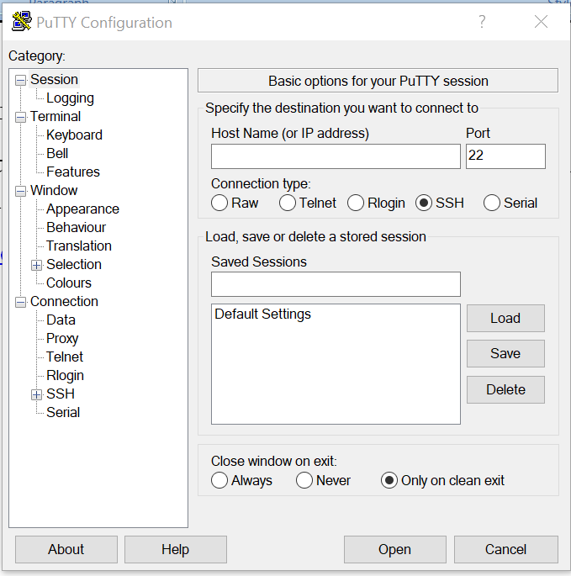

2. Upload the key pair in (ppk) format in PuTTy configure and follow the following commands when it gets active.

3. login as [ec2-user@publicipadress. -for](mailto:ec2-user@publicipadress.-for) amazon Linux

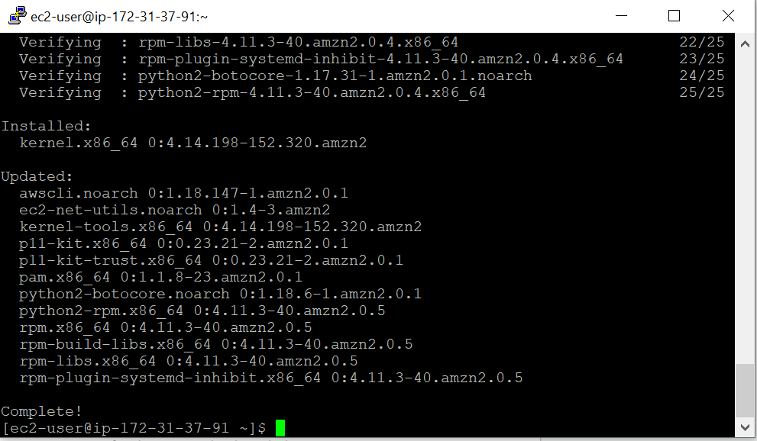

**Steps to Deploy a Web Application on EC2 Instance through S3 Bucket.**

1. Create S3 Bucket through AWS S3 in service .
2. Upload the files of the app you want to deploy .
3. 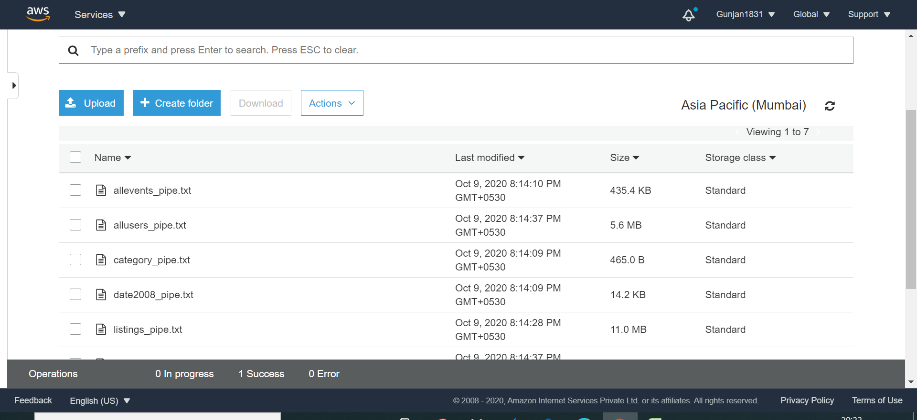
4. Create IAM Role with S3 Full Access Permission.
5. Through Putty, connect EC2 instance through SSH,
6. Create the security group with SSH, HTTP,HTTPS inbound rules.
7. Key pair should be checked.
8. Launch EC2.
9. Now login as user name.
10. Follow the following commands to deploy your web application stored in S3 to EC2 instance.
    * + sudo su
      + yum update –y
      + yum install httpd –y (Installing Apache)
      + chkconfig httpd on
      + cd /var/www/html
      + aws s3 sync s3:// bucketname /var/www/html/
      + service httpd start

10.When you will copy the provided public IP Address of your Instance your deployed web app will run. 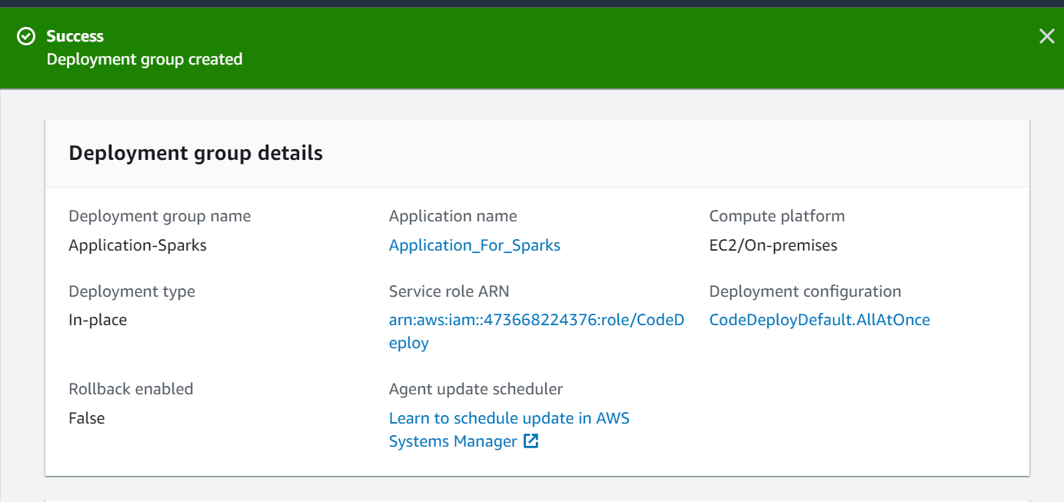

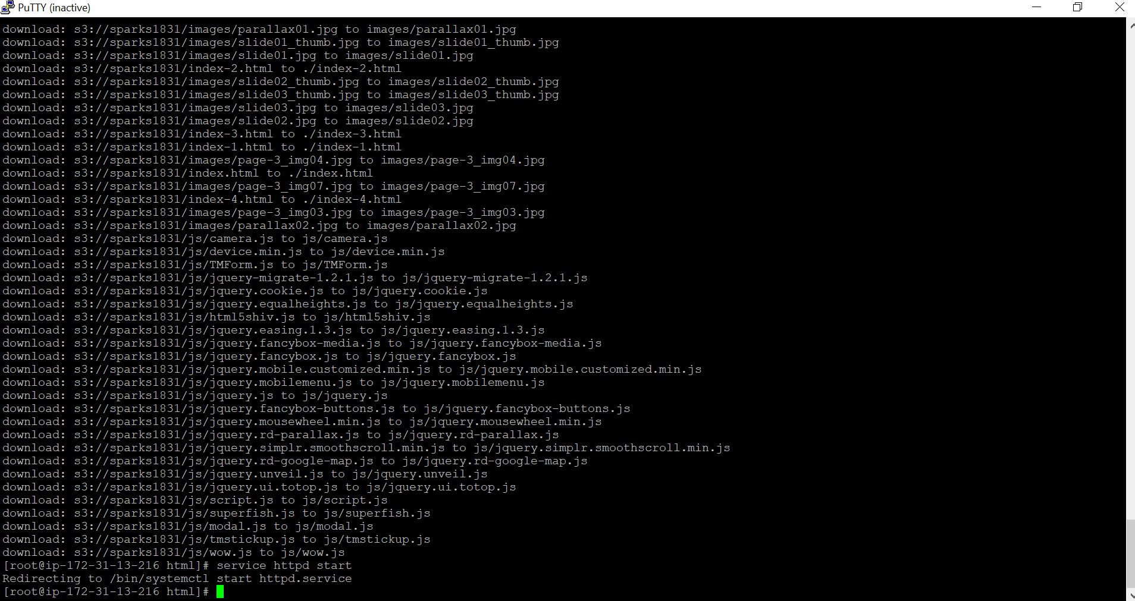

Commands in EC2 terminal to Deploy Application using Apache

**AMAZON RELATIONAL DATABASE SERVICE**

* Amazon Relational Database Service is a distributed [relational database](https://en.wikipedia.org/wiki/Relational_database) service by [Amazon Web Services](https://en.wikipedia.org/wiki/Amazon_Web_Services) (AWS).
* It is a [web service](https://en.wikipedia.org/wiki/Web_service) running ["in the cloud"](https://en.wikipedia.org/wiki/Cloud_computing) designed to simplify the setup, operation, and [scaling](https://en.wikipedia.org/wiki/Scalability) of a relational database for use in applications.
* Administration processes like patching the database software, backing up databases and enabling [point-in-time recovery](https://en.wikipedia.org/wiki/Point-in-time_recovery) are managed automatically.
* Scaling storage and compute resources can be performed by a single [API](https://en.wikipedia.org/wiki/API) call as AWS does not offer an SSH Connection to RDS instances.

**STEPS TO CREATE RDS INSTANCE**

**LINK** 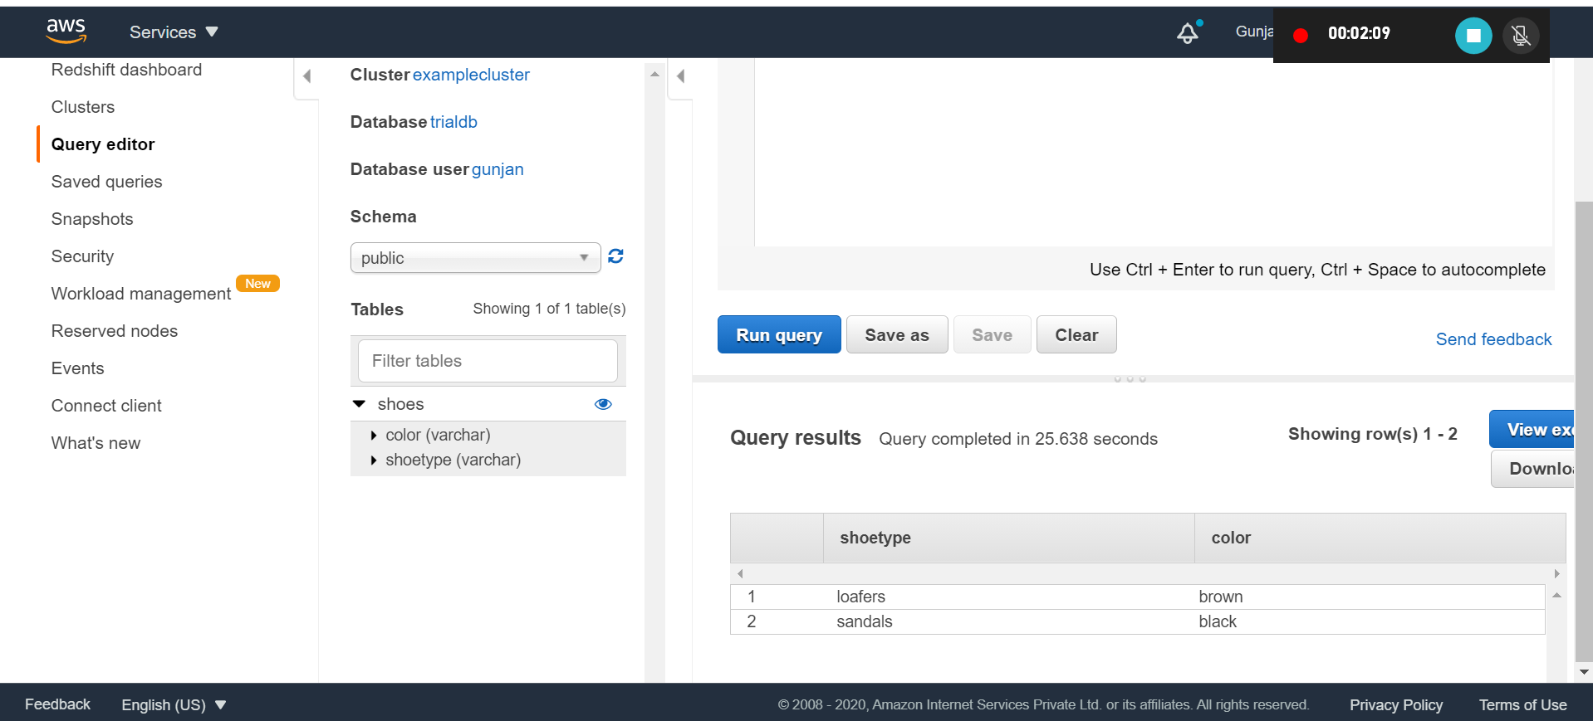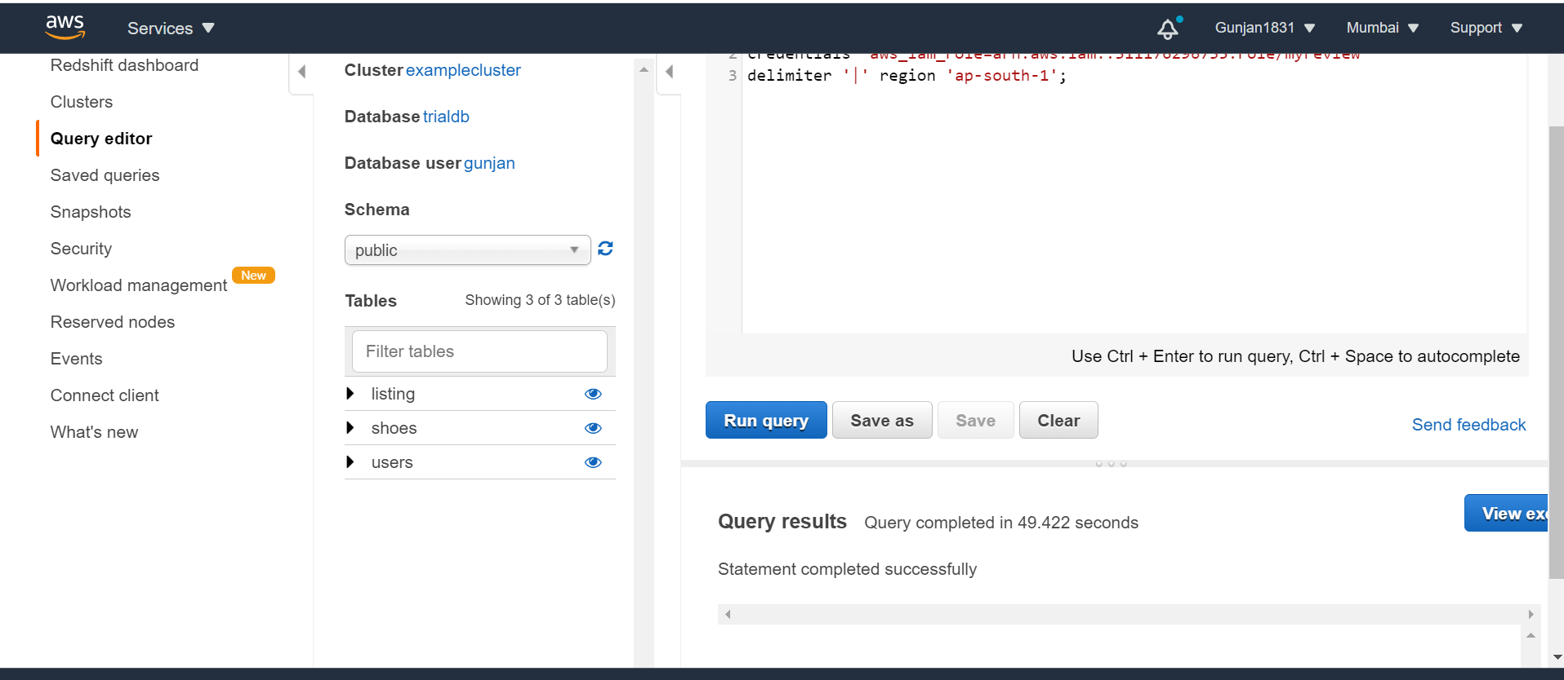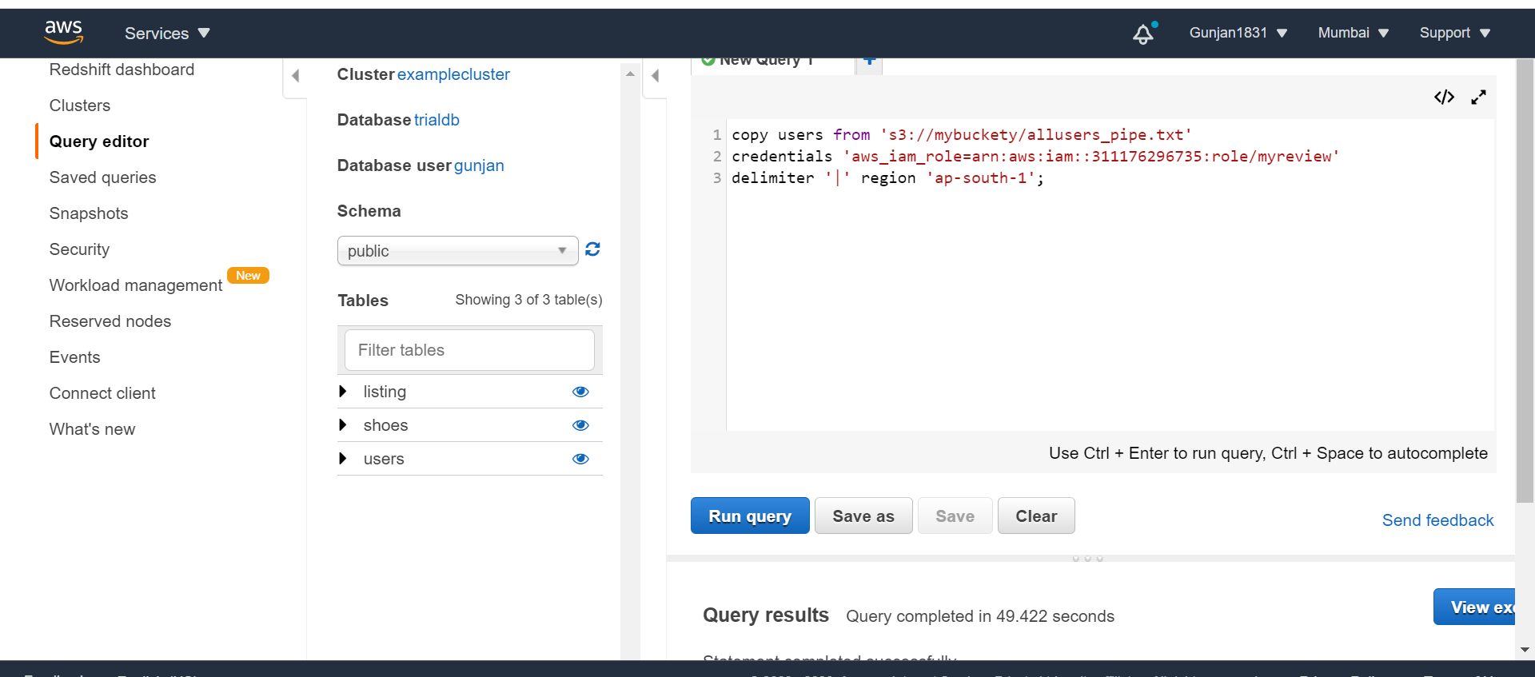[https://docs.aws.amazon.com/AmazonRDS/latest/UserGuide/CHAP_Tutorials.WebServerDB.CreateDBInstance.html](https://docs.aws.amazon.com/AmazonRDS/latest/UserGuide/CHAP_Tutorials.WebServerDB.CreateDBInstance.html)